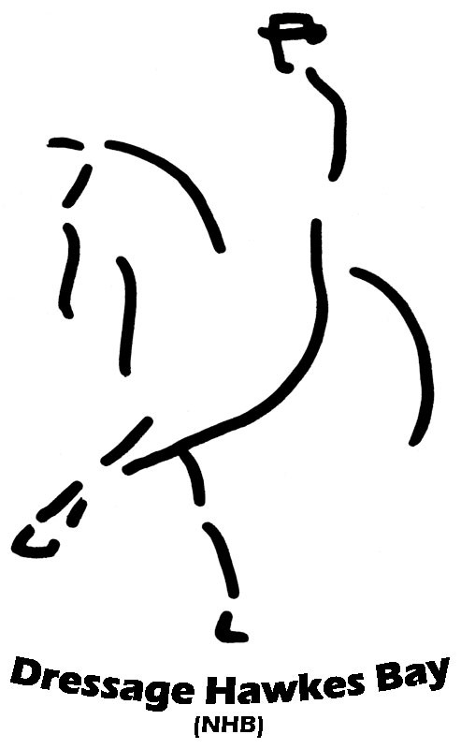
20Dressage Hawke’s Bay (NHB)
Sunday 9th February 2014
Reins Arena, Ormond Road, Hastings

Graded Classes Tests Graded Classes Tests
Class 1 Level1 Pony 1A Class 11 Level 1 Pony 1C
ENTRY FEES
Non Graded $12 per test
Level 1 & 2 $14 per test
Level 3 $17 per test
Level 4, 5, 6 $20 per test
Level 7 & above $22 per test

ADMIN LEVY – per Horse/Pony
Dressage HB Members - $12.00
Non Members - $16.00
(Includes ground levy)

PAYMENT: Internet payment can be made to ANZ 01-0691-0045426-00 using riders name as reference
OR send cheque made out to
Dressage Hawkes Bay (NHB)

ENTRIES CLOSE –
29th January 2014 at 5pm

SEND ENTRIES TO – Diane Davidson, 3 Rochester Street, Tamatea, Napier
ONLINE ENTRIES –
www.main-events.com

Inquiries to – Diane Davidson
021 2056533, 06 8434781 or email dressagehb@gmail.com
DRAW AVAILABLE – www.sportsground.co.nz/dressagenhb as from Tuesday 4th February 2013
Class 2 Level 1 Horse 1A Class 12 Level 1 Horse 1C
Class 3 Level 2 Pony 2A Class 13 Level 2 Pony 2C
Class 4 Level 2 Horse 2A Class 14 Level 2 Horse 2C
Class 5 Level 3 Pony 3A Class 15 Level 3 Pony 3C
Class 6 Level 3 Horse 3A Class 16 level 3 Horse 3C
Class 7 Level 4 4A Class 17 level 4 4C
Class 8 Level 5 5A Class 18 Level 5 5C
Class 9 - Level 6 – Test of choice Class 19 Level 6 – Test of choice
Class 10 & 20 Level 7 & above – Test of choice

Non Graded Classes – OPEN TO ALL (C8) Ribbons Only
Class 21 Horse & Pony 1A
Class 22 Horse & Pony 1C
These classes may be split between horses and ponies if sufficient entries

Prize Money Sweepstakes
Prize Money will be paid into the account entry cheque is paid with unless
you send details of an alternative account.

Conditions:-
- ESNZ rules apply
- Entries received after 5.00pm on 29th January 2014 will incur a late
fee of $5.00 per class.
- Late Entries only accepted to replace scratchings
- The organising committee reserves the right to alter or cancel
the programme or prize money, within ESNZ rules.
- The organising committee reserves the right to substitute
prize money for vouchers or prizes
- Scratchings on the day please phone/txt 021 1306957
- Scratchings prior to the start of the competition must be confirmed
in writing requesting a refund by 16th February 2013 to qualify for a 75% refund
- Pony Riders please refer to Dressage NZ rules 463.3
- Dogs not permitted on the grounds
- Local Riders MUST provide a rider Assistance form or entry will not be accepted.
- Yards ($10 per day) there is only a limited number of yards available..
- Entries for Graded Classes must be on the official ESNZ entry form and include current horse registration and
membership numbers.
- Entries for Ungraded classes – Please use the unregistered entry form available on the “Forms” tab on our
website www.sportsground.co.nz/dressagenhb
- Bridle numbers, competition numbers or ID tags MUST be worn refer to our website for more details.
- Horses/Ponies restricted to 3 tests per day
RIDERS MUST CLEAN UP AFTER THEMSELVES AND THEIR HORSES

